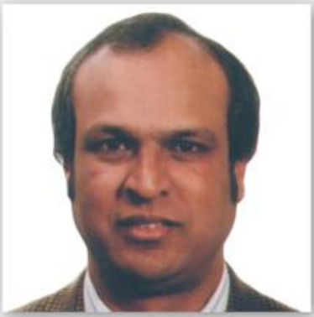
Bahadoor Viswaraj: "USAFIS Was Always In Contact With Me"
It’s a great pleasure for me to thank USAFIS for what they did in helping me to be a winner of the DV lottery 2015, the USAFIS was always in contact with me during the whole process. I can really say that they are very wonderful in their duties. I’ve been waiting for a long time thinking that they are scam organization but in fact, I was wrong and today I and my family are green card holders. Thank you USAFIS.”

